**240840325020**

**HIVE:**

Question 1:

1. Select a.name from airportproj a join routeproj r on a.airportID=r.airlineID where r.dest_airport_id=a.airportID and r.src_airport_id=a.airportID;

select a.name from airportproj a join routeproj r on a.airportID=r.dest_airport_id where r.dest_airport_id is null limit 15;

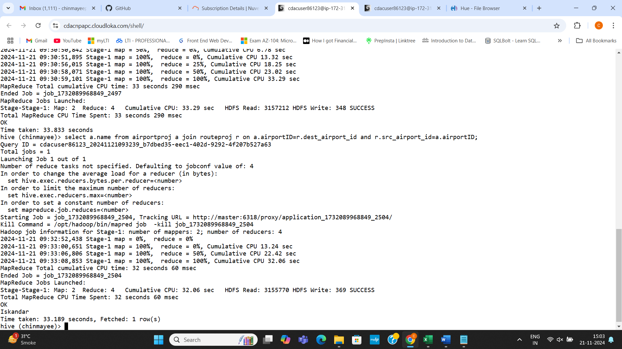

1. Equipment

Select distinct equipment from routeproj limit 15;

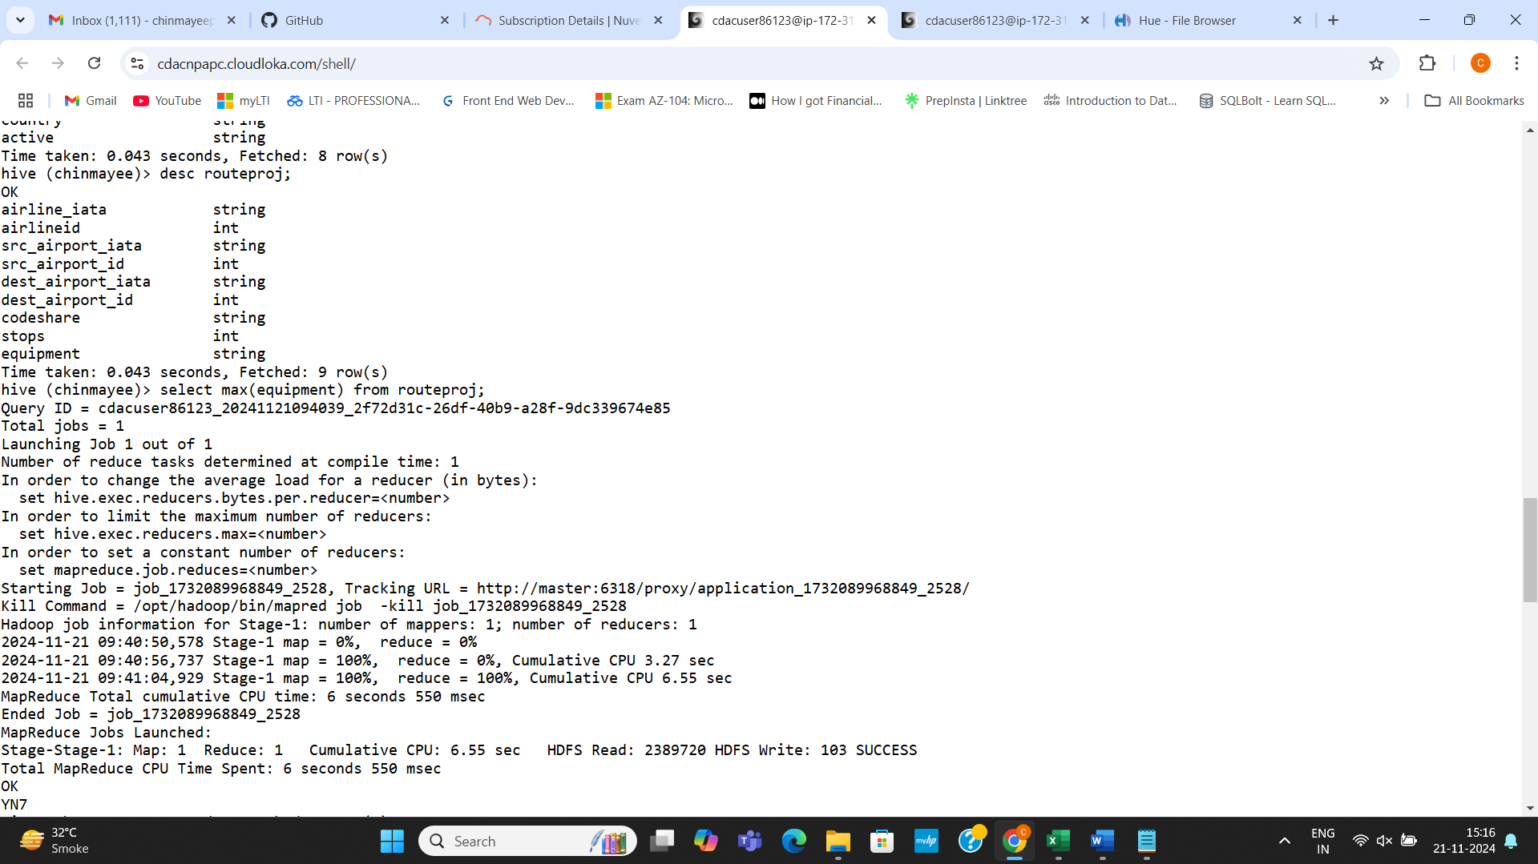

Question 2:

1. create table Source_Airport(airline_iata String, airlineid int,src_airport_iata string, src_airport_id int,dest_airport_iata string,dest_airport_id int,codeshare string,stops int,equipment string)

row format delimited

fields terminated by ','

stored as textfile;

hadoop fs -put routes.dat /user/hive/warehouse/Chinmayee.db/Source_Airport

set hive.exec.dynamic.partition.mode=nonstrict;

set hive.exec.dynamic.partition=true;

1. create table routepart(airline_iata String, airlineid int, , src_airport_id int,dest_airport_iata string,dest_airport_id int,codeshare string,stops int,equipment string)

partitioned by (src_airport_iata STRING)

row format delimited

fields terminated by ','

stored as textfile;

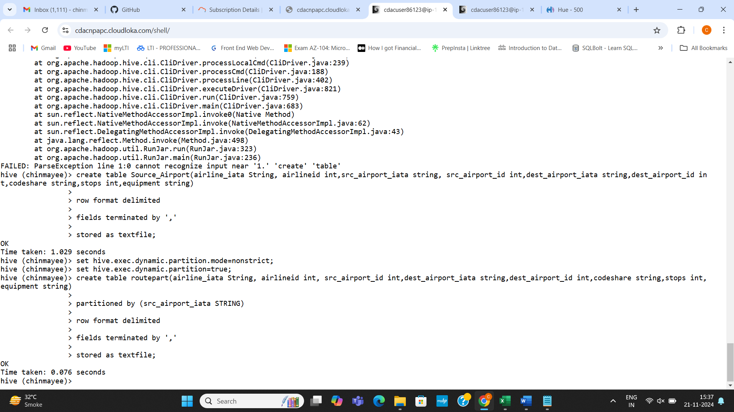

1. select src_airport_id, dest_airport_id from routepart where src_airport_iata='LAX';

hive was not working session closed error

**SPARK**

**1.**

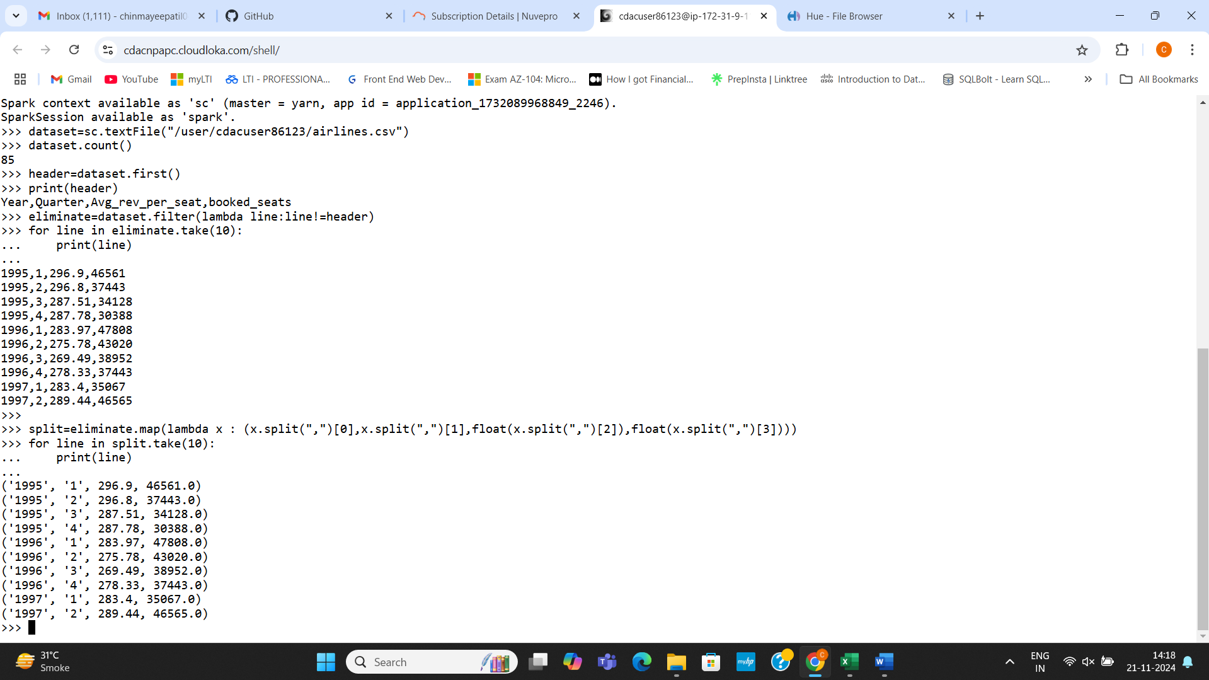

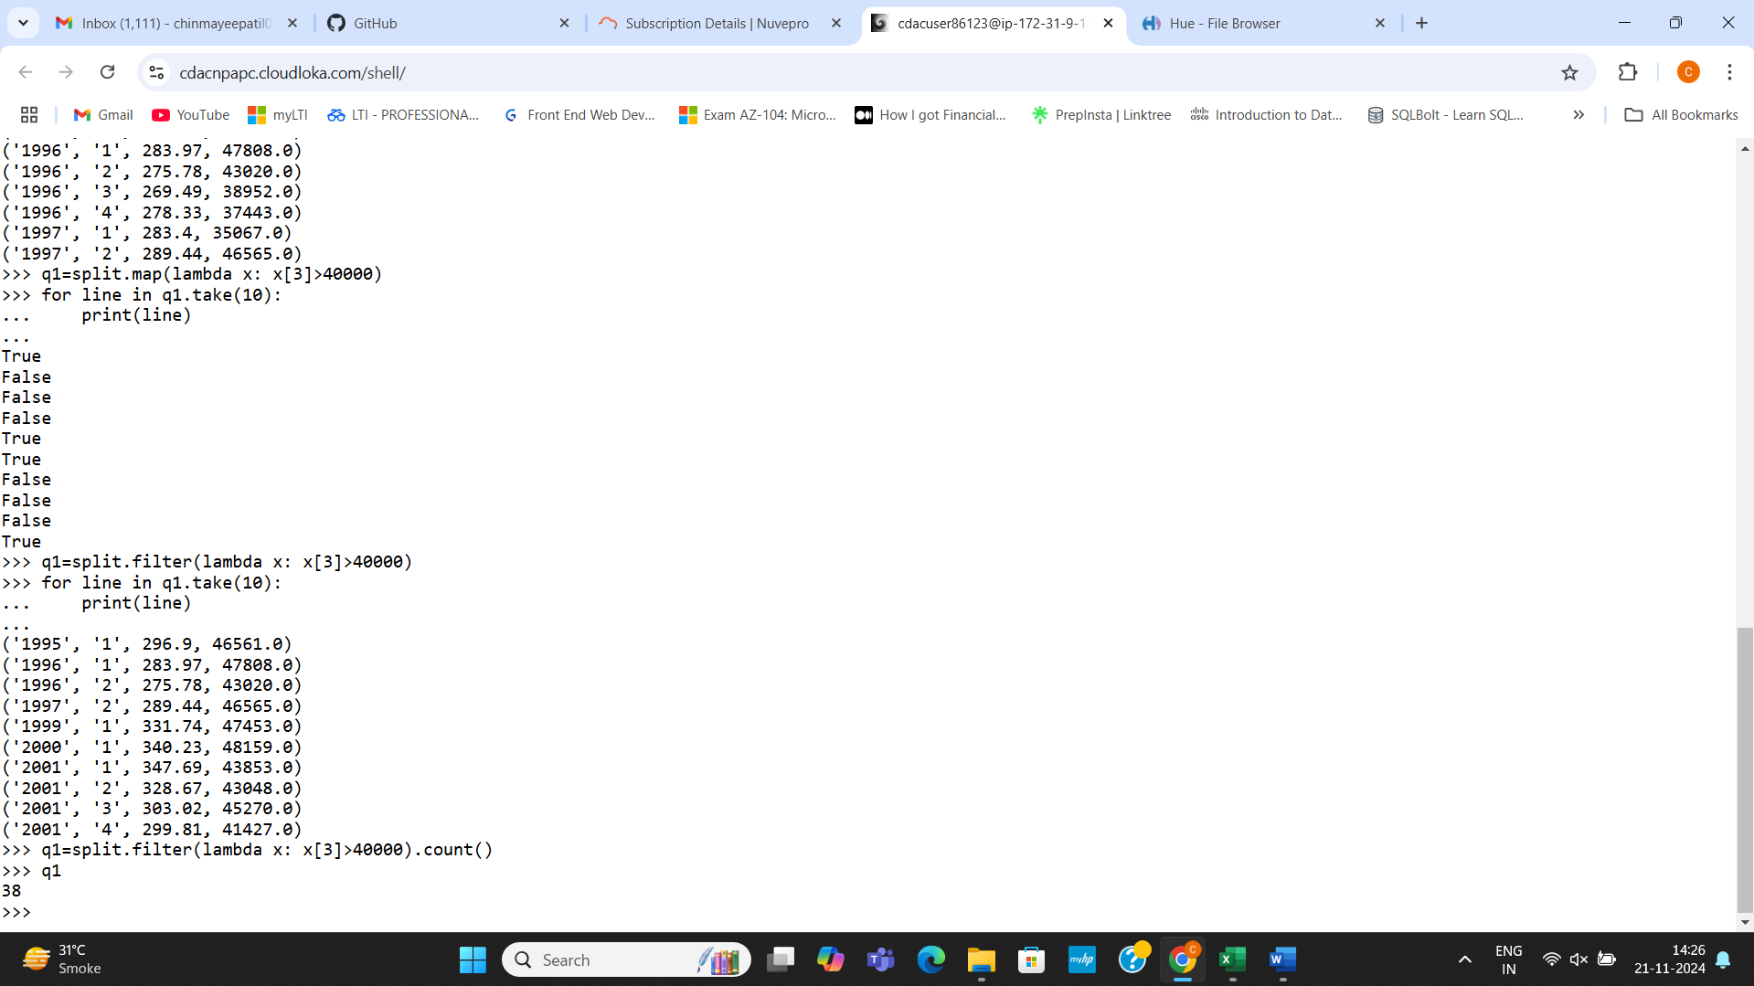

Question 2:

1. Min,max and average

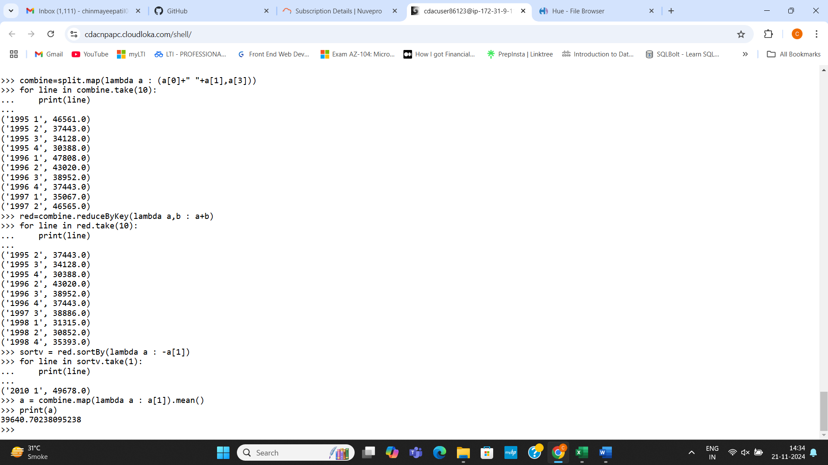

b=combine.map(lambda a: a[1].max()

print(b)

c=combine.map(lambda a:a[1].min()

print(c)

1. More than 290

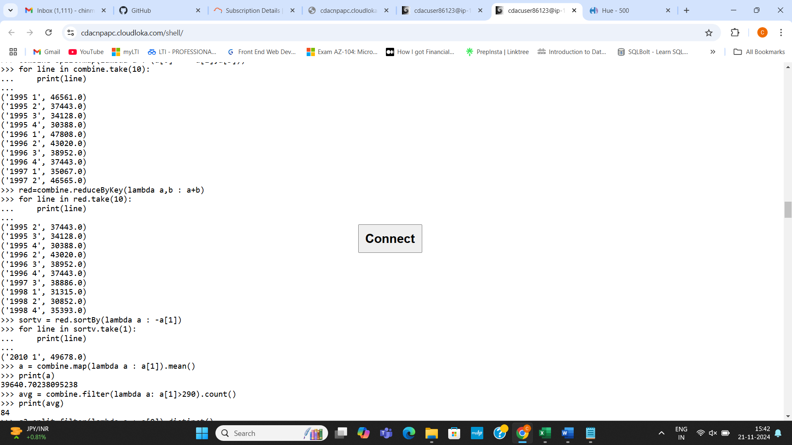

1. combine=split.map(lambda a : (a[1],a[3]))

print(combine.take(4))

1. combine=split.map(lambda x : (x[0],x[1]))

c=combine.reduceByKey(lambda a,b : a+b)

for l in c.collect():

print(l)